1.0 Introduction

There are three basic purposes for this Green Corridor project which is proposed for a specific 6 block section of Lafayette Street in the Bronx. These purposes are:

- To reduce the amount of wet weather storm runoff entering the existing combined sewer system,

- To provide a continuous planter bed within the sidewalk area of the street for the beautification of the existing streetscape, and

- To collect surface water from the street roadway and sidewalk surfaces that would be made available for use by the plants in the planter bed through both subsurface capillary action and supplemental surface irrigation.

The descriptions, calculations and drawings referenced in this report were prepared to demonstrate a method by which storm water runoff to the existing sewer would be significantly reduced or eliminated for this particular street area. However, the methodology developed in this report would be applicable for other street areas as well.

By reducing wet weather runoff to the sewer, the surcharge loading on the wastewater treatment plant would be reduced, thus increasing the effective capacity of the plant and minimizing the potential for violations of the pollution standards at the receiving waters.
Even with regulator structures, which are designed to divert dry weather flow from combined sewers to the wastewater treatment plants, a very substantial amount of storm water enters the sanitary interceptor sewers, and a substantial portion of sanitary flow mixed with storm flow is discharged to receiving waters without treatment. Studies of groundwater and surface flow infiltration to sanitary sewers have shown that even a small trickle flow over an extended period of time can result in a large volume of water at the treatment plant. As more and more “green corridor” projects are implemented, the effect of load reductions at the treatment plants would become more noticeable.

2.0 Drainage Methodology

The proposed method for reducing street runoff from the sewer under the “green corridor” concept is to divert the runoff to temporary storage in 10 foot wide open graded stone beds overlaid by a 10 foot wide planter bed in the sidewalk area on each side of the street. The stone beds would be enclosed in filter fabric on top, bottom and sides to keep fine soil and sediments from entering the stone beds. Above and along both sides of each stone bed would be developed a continuous planter bed, 14 feet wide with a special 3 to 5 foot deep organic soil with moderate permeability, high porosity and an organic content of at least 5 percent. The proposed drainage system is shown in the plan of the modified Lafayette Avenue street layout on Drawings C-201, C-202 and C-203 with details shown on Drawings C-204, C-205, and C-206.

The planter bed would be framed at the surface with standard granite blocks in sand bedding, similar to the standard street tree planting detail of the NYC Department of Parks and Recreation (NYCDPR). The planter would be filled with a mixture of mesophylic shrubs and trees, the roots of which would access the water from the planter soil via capillary action from the water stored in the stone bed below. The sidewalk from the building line and from the curb line would be pitched toward the planter surface, which would intercept the runoff and provide a permeable surface for infiltration of the water into the planter soil. At regular intervals across the planter strip, a 5 foot wide concrete sidewalk would be installed to facilitate lateral movements of pedestrians and workmen with handtrucks from the stores and residential buildings to the curb frontage.

To assure the maximum capture of runoff from the street and sidewalk areas, especially on steep slopes such as this project has, the street runoff would be collected in 8 catch basins on each block. Four NYCDEP standard double catch basins would be installed at the curb, and four NYCDPR standard catch basins would be installed in the sidewalk planter strip, located at midblock and at the downstream end of each block. The hydraulic control devices in the outlet pipes in both types of catch basins would be modified from the standard design to provide maximum discharge capacity for minimum head. The runoff from each catch basin would be conveyed to 6 foot diameter combination seepage /storage basins. After the irrigation storage sump in the lowest level of the combination basin is filled with the runoff from each storm, the water would rise into the perforated seepage basin and discharge directly into the stone beds. The design rationale for catch basins and discharge piping is described in Sections 7.1 and 7.2 below.

3.0 Proposed Street Geometry

Based on a traffic study by the Sam Schwartz Company, the sidewalks in the residentially zoned blocks would be extended from 20 feet to 30 feet wide, and in the industrial zones, to 25 feet wide. Lafayette Avenue is 100 feet wide, so the street width curb to curb would be 40 feet in the residential zones and 50 feet in the industrial zones. The “Street Layout Plan” on Drawings C-111, C-112 and C-113 indicates the proposed street geometry, and the “Street Grading Plan” on Drawings C-601, C-602 and C-603 indicates the proposed street grading. These drawings have been prepared for submission to NYCDOT for approval of the proposed street geometry and grading.

Because of the shift in the curb towards the center of the street, the grades and cross slopes of the existing sidewalks and streets would be significantly affected. Because major portions of the existing sidewalk could not be designed with sufficient continuous cross slope to drain toward the curb, the sidewalks would be designed to pitch from the building line and from the curb line to the center of the sidewalk area. The runoff from the entire sidewalk would thus be collected in a proposed continuous planter bed, which is described in Section 5 below.

Much of the runoff water in the planter bed swale would infiltrate directly through the sand bedding of the standard granite block pavers. To collect flow in excess of the planter bed infiltration capacity, drop inlet structures complying with NYCDPR standard details would be installed in the swale at the middle and at the end of each block. These inlets would be connected by 8” pipes to the proposed standard NYCDEP seepage basins, which are described in Section 7.3 below.

3.1 Traffic Analysis and Recommendations

Data Collection and Observations
The Sam Schwartz Company (SSC) conducted manual turning movement and pedestrian counts at the intersection of Lafayette Avenue and Edgewater Road on one weekday (Thursday, June 19, 2003) from 7-10am, 12-2pm, and 4-7pm and on one Saturday (June 21, 2003) from 11am-4pm. The results are shown on Figure T-1 below.

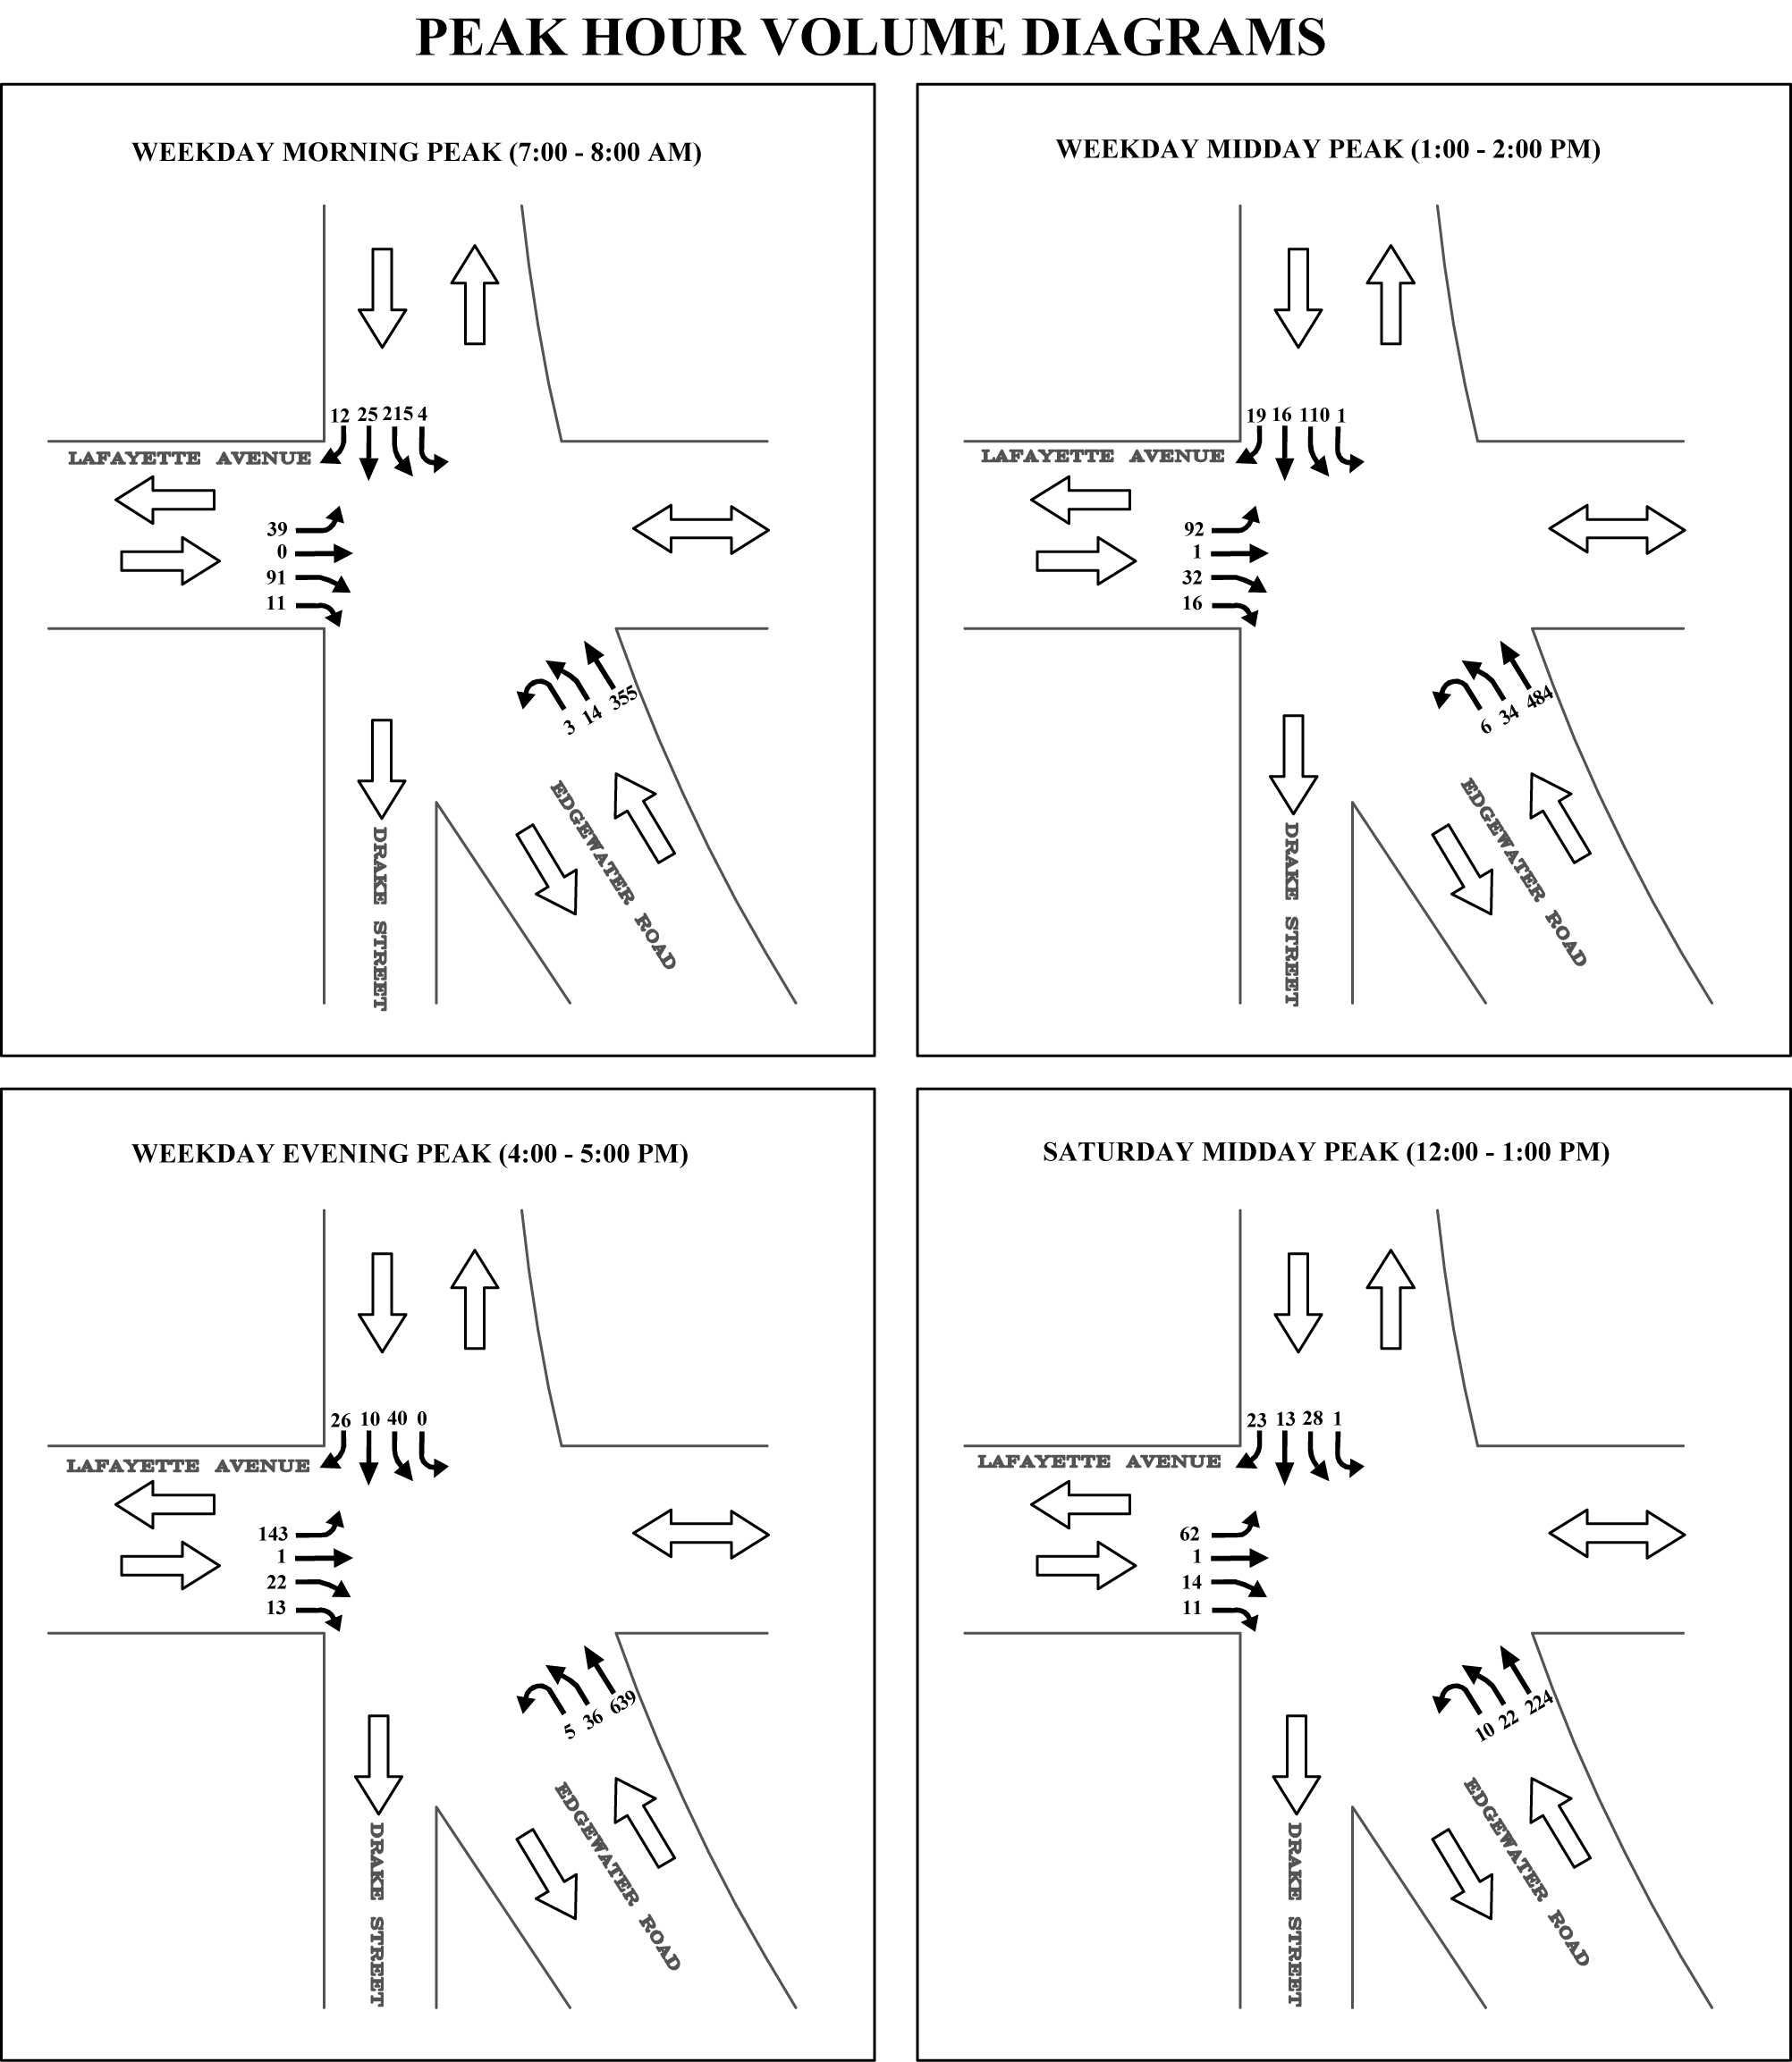

Figure T-1: Peak Hour Volume Diagrams

Traffic data collection also included one week of continuous 24-hour automatic traffic recorder (ATR) counts at the three approaches on Lafayette Avenue and Edgewater Road. Northbound Edgewater Road is the most heavily traveled approach with a peak volume of approximately 850 vehicles in the early afternoon (2:30-3:30 pm). Southbound Edgewater carries significantly less traffic with a peak of approximately 300 vehicles in the early morning (5:30-6:30am). The eastbound Lafayette approach carries a maximum of 200 vehicles in the evening peak hour (4-5pm).

An on-street parking accumulation study was performed on Lafayette Avenue between Faile Street and Edgewater Road concurrent with the manual turning movement counts. The maximum observed parking utilization on the four surveyed blocks of Lafayette Avenue was 77% on a weekday and 58% on a Saturday.

Land uses were recorded and curb cut activity was observed on Lafayette Avenue. These observations helped tailor the street and sidewalk design to the adjacent activities by identifying two distinct zones. The blocks between Hunts Point Avenue and Longfellow Avenue are residential, with a school, a church, and some ground floor retail. The blocks between Longfellow Avenue and Edgewater Road are mainly used by light industrial food distributors.

Loading practices were observed on Lafayette Avenue between Longfellow Avenue and Whittier Street. Tractor-trailer trucks were photographed blocking all of westbound Lafayette and part of the eastbound side of the road as they docked at a beverage distributor facility. For up to an hour, trucks blocked the street and sidewalk, forcing pedestrians and vehicles to blindly cross into opposing traffic to bypass the obstruction. Research of the building codes for this block revealed that the activity is legal, however, it is not recommended that this activity continue. Therefore, the proposed redesign of Lafayette would safely accommodate truck loading by providing extra width in the moving lane for double-parked trucks. Tractor-trailers would no longer be able to park perpendicular to a loading dock on Lafayette.

Traffic Analysis
SSC performed Highway Capacity Software (HCS) analyses during the morning, midday, and evening peak hours at the stop-controlled intersection of Lafayette and Edgewater to evaluate existing traffic conditions. The results of these analyses are shown in Table T-1 below. The HCS program calculates the seconds of delay experienced by vehicles at an intersection and assigns a corresponding level of service (LOS) grade.

LOS grades A, B, and C are generally considered to be acceptable and correspond to between 0 and 25 seconds of delay per vehicle at unsignalized intersections. Currently, the northbound and southbound approaches of Edgewater Road operate at level of service (LOS) B or better during the weekday morning, midday, and evening, and Saturday midday peak hours. The eastbound approach of Lafayette Avenue operates at LOS C during the weekday evening peak hour, and at LOS B during all other times.

Table T-1: Existing Condition LOS
Street Name | Dir. | Lane Group | Peak Hour
Street Name | Dir. | Lane Group | WKDAY AM | WKDAY MD | WKDAY PM | SAT MD
Edgewater Road | NB | LTR | A | A | A | A
Edgewater Road | SB | LTR | B | A | A | A
Lafayette Avenue | EB | LT | C | C | C | B
Lafayette Avenue | EB | TR | A | A | B | A

Due to low volumes on Lafayette, it was determined that the roadbed could be narrowed from two lanes in each direction to one. Southbound Edgewater could also be reduced from two lanes to one lane; however, two-lanes would be maintained at the intersection to accommodate heavy truck traffic and provide future flexibility. With the narrowing of Lafayette and signalization of the intersection, the LOS of all approaches would be B or better during all analyzed time periods, as shown in Table T-2 below.

Table T-2: Signalized and Narrowed Condition LOS
Street Name | Dir. | Lane Group | Peak Hour
Street Name | Dir. | Lane Group | WKDAY AM | WKDAY MD | WKDAY PM | SAT MD
Edgewater Road | NB | LTR | B | B | B | B
Edgewater Road | SB | LTR | B | B | B | B
Lafayette Avenue | EB | LTR | B | B | B | B

While likely not warranted by vehicular volumes, it is proposed that the intersection of Lafayette and Edgewater be signalized to facilitate pedestrian crossings. A public park and boathouse are planned for the space on the Bronx River at the end of Lafayette Avenue. These uses will generate more pedestrian activity in the area. Signalizing the intersection would provide a safer crossing for pedestrians intending to use what will become attractive waterfront spaces in the future.

3.2 Roadway Design Recommendations for Lafayette Avenue

A variety of schemes for the redesign of Lafayette Avenue were considered, including medians of varying widths, expanded sidewalks, and hybrid solutions with both treatments. Bikeways were also considered as potential additions to each scheme. The pool of schemes was narrowed to three: a wide median, a one-sided corridor, and a two-sided corridor, as shown on Figure T-2 below.

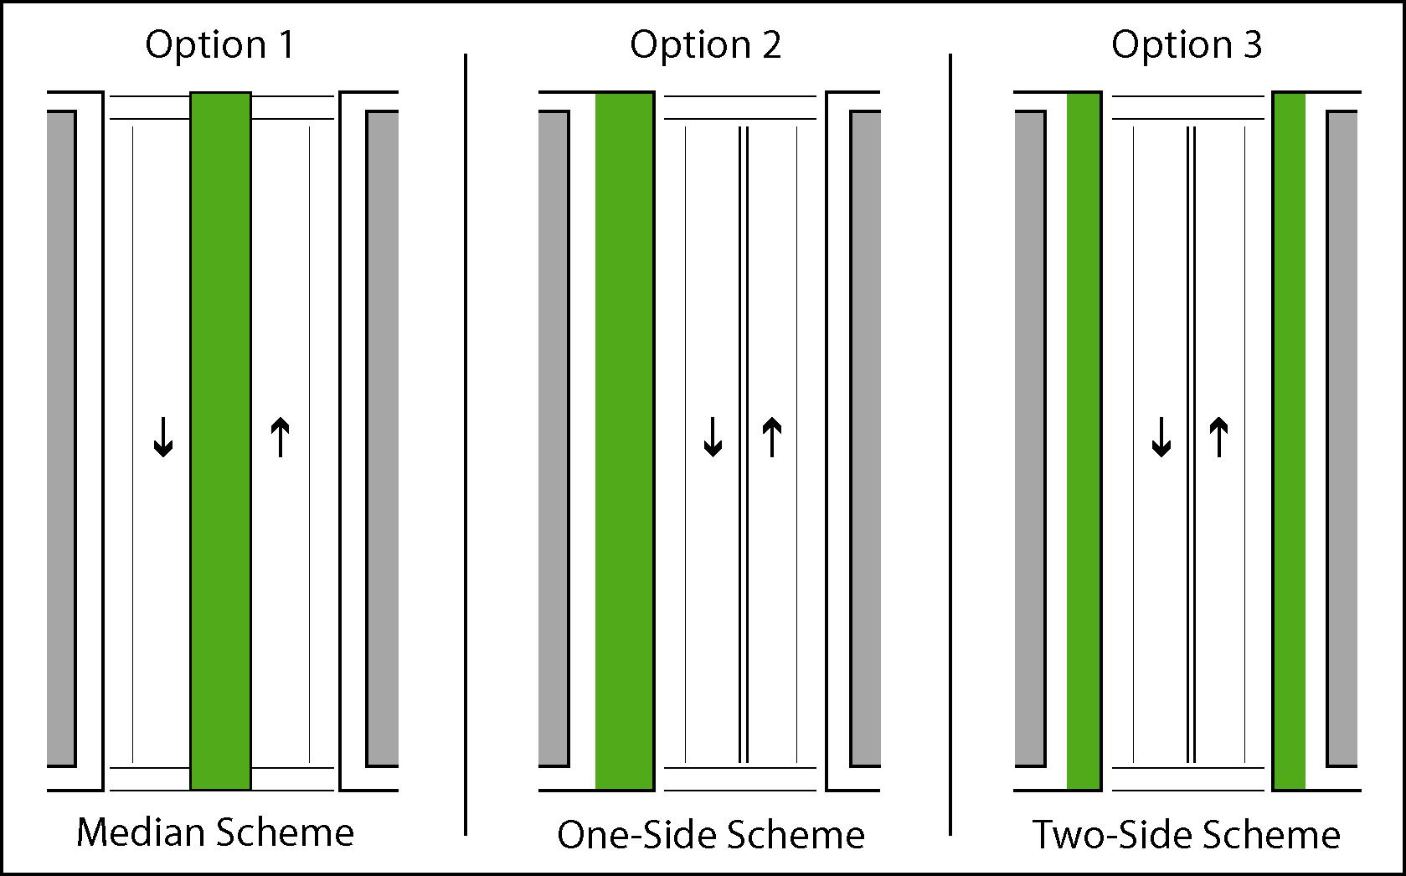

Figure T-2: Options for Green Corridor location (one block sample)

The first option explored the possibility of placing the infrastructure for the Green Corridor in a 20-foot wide median down the center of Lafayette Avenue. This treatment would improve the street environment by calming traffic and reducing pedestrian crossing distances. However, the median would make infrastructure improvements expensive since the design would have to accommodate existing utilities occupying the space. The median would also reduce curb cut access and create an isolated open space that would not be as usable as space added to the sidewalk area.

A second option explored the possibility of locating the Green Corridor on one side of Lafayette. This treatment would create the largest contiguous open space of all of the schemes. However, it is not as readily replicated on other city streets as a symmetric design. If the Green Corridor were located on the north side it would inhibit access to active loading docks. The street and infrastructure would have to be designed to channel runoff from the narrow side to the Green Corridor stormwater catchment zone, further reducing the scheme’s replicability on other city streets. Further, the Green Corridor section of Lafayette Avenue would no longer align with the section of Lafayette on the opposite side of Hunts Point Avenue.

The final option, a two-sided Green Corridor, was ultimately chosen because of its replicability, equal treatment of both sides of the street, maximization of usable open space, and safe accommodation of truck loading activity. The design appears on the “Street Layout Plan” on Drawings C-111, C-112, and C-113, and a description follows:

The upper half of Lafayette was designed to have one 12’ moving lane and one parking lane on each side. The lower half of Lafayette was designed with one 17’ moving lane and one parking lane in each direction to accommodate possible double parking for trucks in front of industrial use buildings. These changes would result in an increase in sidewalk widths from 20’ to 25’ wide in the industrial zone and 30’ wide in the residential zone. To facilitate pedestrian movements from Hunts Point Avenue to the park on the Bronx River, neckdowns would be constructed on each of the side streets intersecting Lafayette Avenue. One parking space on each curb may be lost due to the reconstruction of Lafayette Avenue.

3.3 Roadway Design Recommendations for the Intersection of Edgewater Road and Lafayette Avenue

Currently, the lanes on Edgewater Road are poorly marked and the intersection is excessively wide; the north and south crossings measure approximately 80 feet and 120 feet, respectively. As the connection between the Green Corridor and the waterfront, the intersection of Edgewater Road and Lafayette Avenue should be redesigned to improve pedestrian crossings and regulate vehicle paths. Two schematic redesign options were considered. One option, shown on Figure T-3, proposes a median and on-street bike lanes for Edgewater Road. A second option, shown on Figure T-4, recommends a green space on the east side of Edgewater Road (Figure 4). Both options assume signalization of the intersection to provide for safer pedestrian crossings.

The first option would create medians on Edgewater Road north and south of Lafayette Avenue. The medians would be widest at Lafayette Avenue (25-30 feet wide) and taper to a narrower width away from the intersection. Edgewater Road would be marked as two 12’ lanes northbound and one southbound 12’ lane flaring into two before the intersection with Lafayette Avenue. The park driveway would be narrowed to 24’ wide to increase sidewalk space. This design maintains existing parking lanes, except north of Lafayette on northbound Edgewater Road, and creates a four-foot painted bikeway in both directions. The proposed curb lines on Edgewater Road change little from the existing condition. The implementation of a bikeway accommodates NYCDOT’s designation of Edgewater Road as part of the bikeway network in Hunts Point.

The second option would narrow Edgewater Road by adding green space to the east side of the street between the road and the railroad tracks. This green space would include a path for a bikeway, which the previous option placed in the street. The green space would have a maximum width of 35 feet and taper away from the intersection at Lafayette Avenue. Edgewater Road would be marked as two 12’ lanes northbound and one southbound 12’ lane flaring into two after the intersection with Lafayette Avenue. Significant sidewalk space would be added to the west side of Edgewater Road at the intersection to reduce crossing distance. It is important to note that the greenway option alters most of the curb lines along Edgewater Road and would impact access to properties on the east side.

Of the two schemes, the greenway scheme provides the greatest improvement to the pedestrian experience while accommodating existing traffic demands. The greenway option anticipates the proposed Bronx Greenway and would create a usable green space for cyclists and pedestrians. In contrast, the median would be mainly uninhabitable and would serve the purpose of greening the area, separating traffic, and providing a pedestrian refuge for a long crossing. While the median option creates slightly more vehicular capacity on southbound Edgewater Road, the greenway option
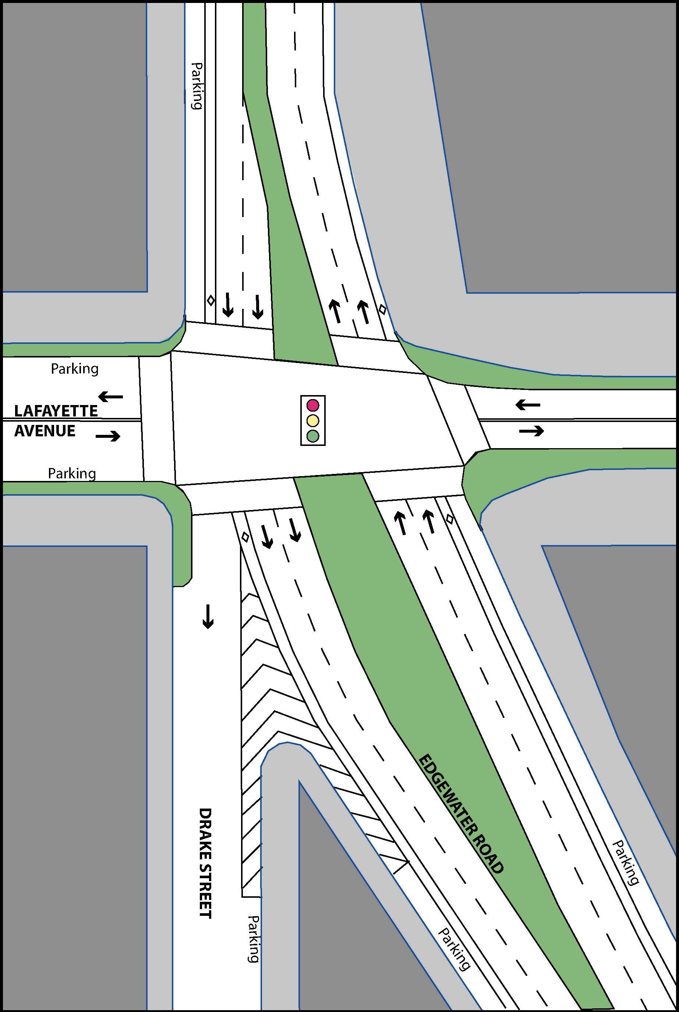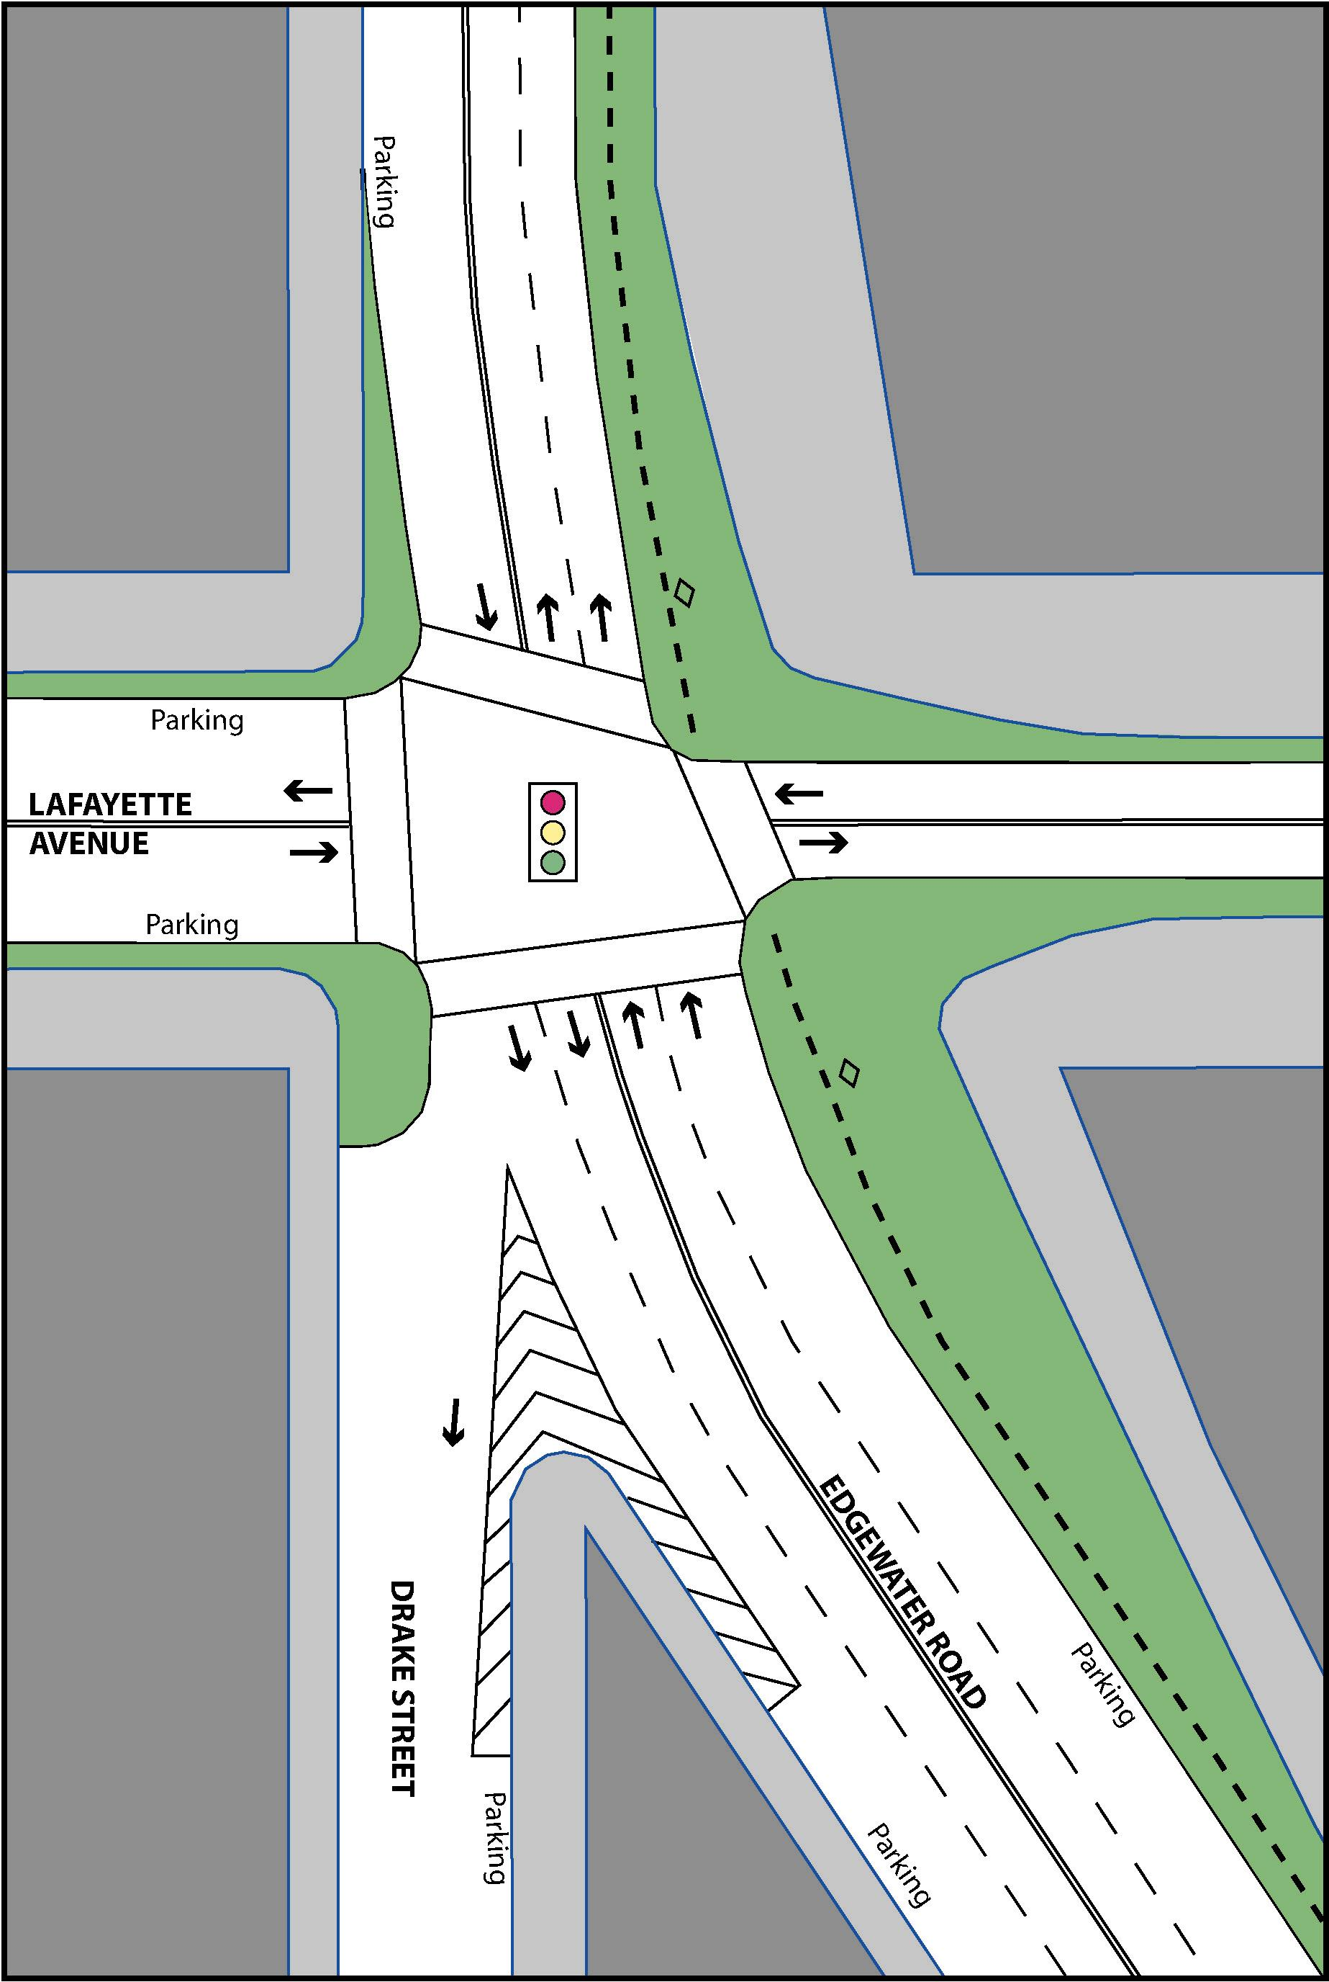
Figure T-3: Median Redesign Option Figure T-4: Greenway Redesign Option

allows for the shortest overall crossing and would enable a pedestrian to cross in one signal cycle. Lastly, the greenway option creates a safer bikeway by separating it from traffic instead of locating it between moving and parking lanes.

- Potential Tree and Utility Conflicts

To minimize existing and future conflicts with utilities in the street, the major portion of the stone beds and planter areas would be located in the sidewalk area. Most sidewalk areas do not have utility mains with which to contend. The flexibility in the design and layout of the stone beds, compared to the inflexibility of rigid pipes and structures, is very important in assuring the continuity of the system. The ease with which it can be installed in areas with potentially unforeseen obstructions and conflicts is a major advantage in assuring the constructability of the system under various types of field conditions encountered during construction.

For this project, all existing street trees were assumed to be removed and replaced in the planter bed with equivalent or better new trees. The stone bed would be placed under and around each tree ball for maximum availability of storm water to move into the roots through capillary action, which is described more fully in section 7 below. The detailed landscape plans for street tree removals and replacement would be submitted to NYCDPR and NYCDOT prior for review and approval as part of the street design process.

The setback of the stone beds by from 5 to 10 feet from the curb would allow for the excavation, installation, repair and replacement of fire hydrants, street light poles, parking meters, utility service valves and other utilities without disrupting the stone bed system. Where excavation is required through the stone beds for future utility services to each building, a special specification and typical detail would be developed to assure that contractors restore the integrity of the stone bed and planter bed system. Compliance by the contractor with these documents would be required as part of the excavation permit.

5.0 Drainage System Maintenance

To assure that the maintenance and repair of the green corridor drainage facilities would be as seamless as possible, most of the elements of the green corridor system are standard design items of the key city agencies which would be responsible for maintenance of the streets and drainage system, including NYCDOT, NYCDEP and NYCDPR. The tree planting bed with its granite block pavers in a sand bed and broken stone bed under the tree root ball would comply with the “Standard Details of Construction” of NYCDOT, which includes a Street Tree Planting Detail that requires a permit from NYCDPR. The proposed drainage catch basins in the planter bed swale would comply with the standard details of NYCDPR, Type C-6.

Normally, each city block contains 2 catch basins at the curb at a maximum spacing of 400 feet to control the runoff from the sidewalk and street areas. For the proposed Lafayette Street project, there would be 4 double catch basins at the curb, in addition to 4 parks type catch basins and 6 seepage basins with 8’ deep irrigation sumps in the sidewalk area. With 4’ deep grit sumps in each catch basin, the total volume of sediment storage per block would be 112 cubic feet (cf) for a normal street design compared to 649 cf for the proposed design, or 5.8 times more sediment capacity. In the multi-stage system proposed for this project, the irrigation sumps would provide an additional sediment capacity of 1,357 cf, which would represent a combined total of 17.9 times more sediment capacity than a normal street design.

The hydraulic control devices inside the street catch basins are not NYCDEP standard design items. However, this should not preclude normal maintenance operations by the NYCDEP. The purpose of these special designs is to obtain maximum flow capacity in the pipes with the absolute minimum required head, as described in Section 7.2 later in this report. These devices comply with the detail for “Concentric Trash Rack and Anti-Vortex Device” in the “New York Guidelines for Urban Erosion and Sediment Control” (see Appendix A, Exhibit 9, for details). The NYSDEC recommends the use of the details in the “Guidelines” in the recently issued “New York State Stormwater Management Design Manual”. The special gas traps and trash devices in the catch basins are designed of standard materials, sections of ductile iron pipe with caps on top, which would be installed in the opening of the standard catch basin just below the street grate.

Standard double chamber catch basin structures are proposed for the street catch basins. The first upstream chamber would capture most of the grit and would provide unimpeded maintenance access for normal cleaning by clamshell or vacuum equipment. The second chamber would provide maintenance access to the hydraulic control devices. Except for a structural beam to support the standard grate inlets, the lower portion of the wall between the chambers would be removed to facilitate ease of access for cleaning or maintenance in both chambers of the catch basin.

The seepage basins would be maintained in a similar manner by which other seepage basins are maintained throughout New York City. Access to each seepage basin would be provided in the sidewalk area by a standard NYCDEP manhole cover. Most of the sediments entering the catch basin would be captured in the sump of the catch basin. Floatables and sediments would be restricted from entering the seepage basin by the upward moving flow required within the vertical trash rack devices.

Within the seepage basins, the flow of storm water runoff into the stone beds would be driven by the water surface in the catch basins. The flow from both street and sidewalk catch basins would enter the sump of the seepage basin. The purpose and design of the seepage basin sump are described in Section 6.3 below. The velocity of upward flow would be significantly reduced within the seepage basin, and fine material that may have passed through the catch basins would settle out of suspension in the seepage basin. At the perforated section of the seepage basin, the flow would be forced to move laterally and then upward through the stone collar around the basin before it could move laterally through the stone beds. In this final stage of upward flow, the stone beds would be protected from sediment by the resistance of the stone media, by another significant reduction in the upward flow velocity resulting in a decrease or elimination of turbulent flow and eddies which tend to keep particles in suspension, and by the resistance of gravity acting on sediment particles. Therefore, the stone beds would be more than adequately protected from sedimentation.

6.0 Hydrology

The area of a typical block on Lafayette Avenue, which is 100 feet wide by 200 feet long with 60 feet wide side streets, is calculated as follows, including the portion of the intersection that drains to Lafayette Avenue.

A = (100')(200') + (2)(½)(30')(100') = 23,000 sq. ft. / 43,560 sq. ft./ acre = 0.53 acre.

6.1 Total Volume of Runoff

The total runoff volume from each block will be evaluated for the 5 year, 10 year and 100 year storms, each of which has a total 24 hour precipitation of 4.5", 5.2" and 7.3", respectively. The required depth in the storage volume in the stone beds would then be determined based on the total runoff volume for each storm frequency. The total runoff volume for the 10 year storm frequency would be the index volume for evaluating the economics of developing deeper storage systems for the less frequent storm events.

The weighted runoff coefficient for a typical block is determined as follows. The total planter bed area with a runoff coefficient of 0.20, is (2 sides)(10' wide)(200' long) = 4,000 square feet. The remaining sidewalk and pavement area, with a runoff coefficient of 0.85, is 23,000 - 4,000 = 19,000 square feet. The volume of runoff is then V = Cw(P/12 In./Ft.)A.

Cw = [(0.20)(4,000) + (0.85)(19,000)] / 23,000 sq. ft. = 0.74

5 year runoff volume: V = (0.74)(4.5 In./12 In./Ft.)(23,000 sq. ft.) = 6,382 cu. ft.
10 year runoff volume: V = (0.74)(5.2 In./12 In./Ft.)(23,000 sq. ft.) = 7,375 cu. ft.
100 year runoff volume: V = (0.74)(7.3 In./12 In./Ft.)(23,000 sq. ft.) = 10,353 cu. ft.

Refer to Section 7.7 for the estimated amount of storage required in the stone beds to control the runoff for each of these storm events based on the estimated discharge for various types of subsoil encountered.

6.2 Peak Flow of Runoff

The peak flow at each of the 8 catch basins in a typical block is determined as follows. The drainage area for each of the 8 catch basins would be (1/8)(23,000 sq. ft.) / (43,560 sq. ft. / acre) = 0.066 acre. The peak flow for each storm frequency, based on the rational formula Q = CIA, is as follows. The peak flow at seepage basins, which receive flow from one street and one sidewalk catch basin, would be twice that at catch basins.

Frequency Peak Flow at Catch Basins: at Seepage Basins:

5 year Q = (0.74)(5.95 In./Hr.)(0.066 acre) = 0.29 cfs Q = 0.58 cfs
10 year Q = (0.74)(6.67 In./Hr.)(0.066 acre) = 0.33 cfs Q = 0.66 cfs
100 year Q = (0.74)(8.85 In./Hr.)(0.066 acre) = 0.43 cfs Q = 0.86 cfs

  - Supplemental Irrigation System

A supplemental irrigation system is proposed to provide water from storm runoff in a sump chamber within the seepage basins. The bottom portion of the seepage basin would be constructed with solid walls and bottom to retain a volume of water that would be available for irrigating the planter bed during dry periods. During every storm event, the inflow from the catch basins would fill the irrigation sump first, then rise and discharge laterally into the stone beds. To provide 6 weeks supply for irrigating at 0.5 inches per week, the total volume of irrigation water would be:

V = (2 sides)(10’ wide)(200’ long) [(6 weeks)(0.5 in./week) / (12 in./ft.)] = 1,000 cu. ft.

Using 6’-0” outside diameter concrete rings for the seepage basins, with 3 seepage basins on each side of the street, the depth, D, of the irrigation sump in each basin would be: A = (pi) r ² = (3.14)(5.33’/2) ² = 22.31 sq. ft., and D = (1,000 cu. ft.) / (2 sides)(3 basins/side)(22.31 sq. ft.) = 7.46 vertical feet, say 8.00 feet of sump depth per basin.

The irrigation system would include a sump pump in each seepage basin, with a quick coupler connection and an electrical control switch in an adjacent sidewalk box. The irrigation system would be operated by the staff responsible for the maintenance of the planter bed. An automated spray, bubbler or drip irrigation system, with automatic rainfall recording gages, would be installed with controls located in sidewalk boxes, or other structures, as required. It is understood that an entity, such as a private maintenance corporation, would be established to perform the operation and maintenance functions for the irrigation system as well as for the plantings, soil and special non-standard drainage systems, unless otherwise directed by the City.

7.0 Hydraulic Design Premise

Each side of the street would operate as an independent drainage system. During each precipitation event, the storm water runoff from the street would collect in the gutter and enter the catch basins. From the catch basins, the runoff would flow first into seepage basins from which the water would enter the continuous stone beds.

As shown in the details on Drawing C-205, the stone beds in the sidewalk would be installed in a manner similar in concept to the level steps of a footing, with check dams to control the water level within each section of the stone bed. When the upstream step of a stone bed fills up, the flow would pass through overflow pipes in the check dam and begin filling the next level step. The number and spacing of check dams are a function of the street slope. All stone beds would be placed level and as shallow as possible to deliver water to the planter area within the root zone of the plants. As shown in Detail 1 on Drawing C-204, the organic soil of the planter bed would be placed on both sides of each stone bed, in a continuous trench from the bottom of the stone bed to the base course of the sidewalk.

During times of storm water storage, the planter soil would make contact with the free water surface at any level within the stone basin. This contact would allow the capillary spaces within the specially designed organic soil to pull water laterally from the stone through the filter fabric into the adjacent planter soil. The relative abundance of humus in the planter soil allows for a large number of smaller capillaries with a radius of approximately 0.02 millimeters. These small capillaries in the soil function to lift water to approximately 3 feet above the free water surface within the stone bed. To assure that the storm water runoff from the street and sidewalk areas is delivered to the stone beds at the shallow depth required for the capillary process to work effectively, special low head flow regulating devices would be designed to fit inside the standard catch basins.

If flow from the catch basins can not be accommodated by storage in the stone bed and infiltration to the adjacent planter soil and underlying subsoil, the excess flow would discharge to the street sewer at the downstream end of each block. The sewer catch basin connection pipes at the receiving manholes would contain portable, battery operated flow metering equipment to record the amount of flow discharged to the sewer. The portable flow meter presently used by the NYCDEP for flow in pipes is the Flo-Tote 3 manufactured by Marsh-McBirney, Inc. of Frederick Maryland. Each unit is small, with a rugged waterproof enclosure containing a recording device and an integral battery pack. The portable unit can be attached to the rungs in the manhole. The electromagnetic velocity and pressure sensor device for each unit is attached to a thin metallic mounting band placed within the outlet pipe. The measurements have an accuracy of 5 percent, and operate successfully for shallow partial flow in the pipe as well as for full pressure flow up to a head of 11 feet.

Between storm water runoff events, the water distributed into the planter bed would rise by capillary action in the planter soil as described above. This water would then be extracted by the roots of plants and evapotranspired into the atmosphere. Evapotranspiration rates would vary seasonally, with higher rates in the summer and significantly lower rates in the winter. In addition to evapotranspiration, water would be absorbed by percolation into the ground. Where existing groundwater and / or bedrock are greater than 2 feet below the bottom of the stone bed areas, discharge by vertical percolation to groundwater would be a major means of disposing of the water detained by storage in the green corridor drainage system. This increase in groundwater flow in turn would add to the base flow of the Bronx River, which has greatly diminished over the course of development of the watershed.

7.1 Catch Basin Design

Standard precast concrete catch basins would be used for street drainage. Double catch basins would be used in the street to provide access for removal of grit and sediment storage in the first upstream chamber, and access for maintenance of the special hydraulic control devices on the outlet pipes in the second chamber. The basins would comply with the NYCDEP “Sewer Design Standards” of 1997, with modifications as required to accommodate the special low head hydraulic conditions for the stone bedding system. The standard grate measures 24" wide by 48" long, and has a capacity of approximately 3.9 cfs for orifice flow with a net open area of 35% and 1" of water on the grate. From Section 3.2 above, the highest anticipated flow at each catch basin is 0.43 cfs. Thus, each grate has more than adequate capacity to capture the runoff in the gutter.

In each catch basin, sand and grit from the street would settle into the sump. Oil and other floatable debris would be contained in the catch basin by hooded trap inlets on the discharge pipes within the basin. The midblock catch basins would discharge by one 8" DIP pipe into adjacent seepage basins, from which the water would rise and saturate the stone bed.

The catch basins in the street at the downstream end of each block would have 2 discharge pipes. The primary pipe would be an 8" DIP pipe flowing from the catch basin into the seepage basin, which would first fill the irrigation sump and then discharge into the adjacent stone bed. A second pipe, also 8” DIP, would act as an overflow pipe, connecting the seepage basins at the end of the upstream block and the beginning of the downstream block. As a last resort, a 12" DIP pipe from the street catch basin would be connected to the manhole of the existing combined sewer. This 12” pipe would have an outlet elevation 4” higher than the 8” pipes, and it would act as an overflow to the street sewer only if the capacity of the stone beds is exceeded. The hydraulic design of these pipes is described in Section 7.2 below. The proposed configuration of these outlet pipes is shown in Details 1 and 2 on Drawing C-206.

7.2 Design of Hydraulic Control Devices

To minimize the potential for fine sediments, oil and floatables from entering the seepage basins and clogging the stone beds, the pipes from the catch basin to the seepage basins would be fitted with trash and sediment control devices. These devices would be similar in design to the “Concentric Trash Rack and Anti-Vortex Device”, from Figure A1.31 in the standard details of the “New York Guidelines for Urban Erosion and Sediment Control”, latest edition. The details of these devices are shown in Detail 1 on Drawing C-206. These devices control sediment by requiring the discharge water to flow upwards in the annular space between the outer trash guard and the inner discharge pipe. To keep floatables from entering the discharge riser under turbulent inflow conditions, a brass screen would be placed in the bottom space between the inner and outer pipes, and at a 45 degree angle to allow self cleaning when the peak flow abates.

Also, by placing the orifice of the discharge pipe in the horizontal plane, the required head to achieve maximum outflow would be minimized compared to the vertical orifice of a standard pipe connection. A vertical orifice requires a head of 2 to 3 pipe diameters above the inlet invert before the pipe would flow full. By contrast, a horizontal orifice operates first as a round weir (similar to the morning glory spillway of the US Army corps of Engineers), and then orifice flow begins to control at a head of approximately 1/2 of the pipe diameter until full pipe flow is achieved.

The hydraulic capacity of the riser pipe outlet is determined by developing a stage-discharge curve for various levels of head above the inlet orifice on the riser. Under weir control, the discharge capacity is Q_{w} = C_{w}L_{w}(H_{w})^{1.5} , where C_{w} is 3.07 for a sharp crested weir, L_{w} is the circumference of the pipe orifice, and H_{w} is measured from the level of the orifice opening. Under orifice control, the discharge capacity is Q_{o} = C_{o}A_{o}(2gH_{o})^{0.5}, where C_{o} is 0.60 for a sharp crested orifice, A_{o} is the area of the pipe orifice, and H_{o} is the head measured from the crest of the orifice. Table 1 below presents the stage-discharge relationships for both the 8" and 12" size pipe risers in the catch basins. As the head increases, the control changes from weir to orifice control as shown in the bold text.

8" DIP: A = 3.1416 R² = 0.349 sq. ft., and C = 3.1416 D = 2.10'
Q_{w} = (3.07)(2.10')(H_{w})^{1.5} = 6.45 H_{w}^{1.5}, Q_{o} = (0.60)(0.349 sq.ft.)(64.4)^{0.5}(H_{o})^{0.5} = 1.68 H_{o}^{0.5}

12" DIP: A = 3.1416 R² = 0.785 sq. ft., and C = 3.1416 D = 3.14'
Q_{w} = (3.07)(3.14')(H_{w})^{1.5} = 9.64 H_{w}^{1.5}, Q_{o} = (0.60)(0.785 sq.ft.)(64.4)^{0.5}(H_{o})^{0.5} = 3.78 H_{o}^{0.5}

Table 1. Orifice Flow Capacity for 8” and 12” Pipes

8" DIP: Head Q_{weir} Q_{orifice} Q_{control}

1" 0.083' 0.15 cfs 0.48 cfs 0.15 cfs
2" 0.167' 0.44 cfs 0.69 cfs 0.44 cfs
3" 0.250' 0.81 cfs 0.84 cfs 0.81 cfs
4" 0.333' 1.24 cfs 0.97 cfs 0.97 cfs
5" 0.417' 1.74 cfs 1.08 cfs 1.08 cfs
6" 0.500' 2.28 cfs 1.19 cfs 1.19 cfs

12" DIP: Head Q_{weir} Q_{orifice} Q_{control}

1" 0.083' 0.23 cfs 1.09 cfs 0.23 cfs
2" 0.167' 0.66 cfs 1.54 cfs 0.66 cfs
3" 0.250' 1.20 cfs 1.89 cfs 1.20 cfs
4" 0.333' 1.85 cfs 2.17 cfs 1.85 cfs
5" 0.417' 2.59 cfs 2.44 cfs 2.44 cfs
6" 0.500' 3.41 cfs 2.67 cfs 2.67 cfs

As shown in the first part of Table 1 above, the 8” riser pipes, with less than 2” of head, have a capacity to convey the 100 year flow of 0.43 cfs from each of 2 catch basins to the stone bedding with no discharge to the sewer. As shown in the second part of Table 1, the 12” pipe connection to the sewer, even if there were no flow to the stone bedding areas, has the capacity to convey the total 100 year flow of 0.86 cfs to the sewer with less than 3” of head above the inlet orifice of the 12” riser pipe. This would provide 9” of freeboard between the water surface above the 12” riser orifice and the top of the catch basin grate.

7.3 Seepage Basin Design

The proposed 6’-0" precast concrete seepage basin would conform to sheets 56A through 56D of the NYCDEP “Sewer Design Standards” of 1997, with modifications as required, including solid precast rings and base for irrigation storage purposes. During normal runoff events, the seepage basins would effectively function to rapidly distribute storm water runoff from the catch basins to the stone beds for temporary storage. Eventual disposal of the stored water would be by percolation into the subsoil, by capillary uptake into the organic soil in the planter beds, and by evapotranspiration from the plants. To assure the eventual disposal by percolation, the base of the annular stone collar around each seepage basin will be installed to lie within a soil classification of 7-65 or better. Refer to the discussion of recent soil borings taken along Lafayette Avenue in Section 7.8 below.

However, if the stone bed under a planter area should become fully saturated at the downstream end of a block, the flow of excess water would be diverted to the next downstream seepage basin. This would be driven by a rising head of water in the stone bed, which would force water upward in the seepage basin. The rising water would then spill over the orifice of the 8” pipe riser which is connected as an overflow pipe to the downstream seepage basin in the next block for distribution to the planter bed in that block. If the next downstream seepage basin is full, the water would continue to rise until it discharged, as a last resort, through the street catch basin into the 12” overflow pipe connection to the street sewer.

7.4 Hydraulic Capacity of Stone Beds

An approximation of the hydraulic capacity for conveying water horizontally through the stone beds would be based on Darcy’s law for flow in porous media (Harry R. Cedergren, “Seepage, Drainage, and Flow Nets”, 1989). The form of Darcy’s law commonly used in engineering is Q = kiA, where “Q” is a flow rate in cubic feet per day, ”k” is the permeability of the porous media in feet per day, ”i” is the slope of the water surface measured in feet vertical per feet horizontal, and “A” is the total cross sectional area of the stone media in square feet. Open graded, or uniform sized clean aggregate has both the highest permeability and the highest porosity or void ratio, which provides the most efficient means for flow and storage capacity. Typical permeabilities for clean, uniformly graded aggregate is indicated in the Table 2 below (Cedergren, pages 188, 356 and 358).

Table 2. Approximate Permeability for Various Types of Aggregate

Common Name Aggregate size Approximate Permeability (feet/day)

Fine sand -- 50
Coarse sand -- 500
Pea gravel 1/4" to 1/8" 5,000

_ 1/2" to 1/4" 10,000
_ 3/4" to 1/2" 40,000
Railroad ballast 1" to 1/2" 80,000

_ 1" to 3/4" 120,000
_ 1-1/2" to 1" 140,000
ASTM C-33, Size #3 2” to 1” >140,000

ASTM C-33, size #3 stone, 2" to 1" nominal size, was selected as the aggregate size for use in the stone bedding for this project. This material is used in seepage throughout New York City, is readily available at competitive costs, and has a long history of stability and drainability. The porosity, or void ratio, for compacted uniformly graded aggregate is approximately 35 percent voids. To assure that fine material above or below the stone beds does not migrate into the stone beds and reduce its permeability and void ratio, filter fabric geotextile, equal to Mirafi 140N, would be used to totally envelope the aggregate. The hydraulic capacity of this filter fabric is examined in Section 7.5 below.

For estimating the rate of flow in the horizontal direction through the stone bedding, the hydraulic capacity for a fully saturated porous media is determined from the Darcy formula, Q = kiA. Using k = 140,000 feet/day for the stone bedding, the average slope “i” of the street on each block, and 15.0 square feet (10’ wide by 1.5’ deep) for the area of the stone bedding, the flow capacity of the stone bedding is as follows. During the relatively short time required for the flow to move horizontally through the stone bedding, the vertical infiltration rate from the stone into the less permeable subsoil is effectively negligible.

The longitudinal flow capacity and the average velocity of full flow in the stone beds for each street segment of Lafayette Avenue would be determined from the following equations, with the results shown in Table 3.

Q = (140,000 ft./day)(i)(15.0 sq. ft.)/ 86,400 sec./day) = 24.31(i), in cu. ft. per sec.

V = Q/A = Q/ (0.35 porosity)(15.0 sq. ft.) = 0.19 Q, in ft. per sec.

Table 3. Longitudinal Flow Capacity in Stone Beds

Street Segment Street Slope, i Flow Capacity, cfs Average Velocity, fps

Hunts Point to 0.038 ft./ft. 0.92 cfs 0.17 fps
Faile Street

Faile Street to 0.045 ft./ft. 1.09 cfs 0.21 fps
Bryant Avenue

Bryant Avenue to 0.128 ft./ft. 3.11 cfs 0.59 fps
Longfellow Ave.

Longfellow Ave. to 0.095 ft./ft. 2.31 cfs 0.44 fps
Whittier Street

Whittier Street to 0.017 ft./ft. 0.41 cfs 0.08 fps
Edgewater Road

From the results above, the stone beds alone in all of the street segments, except for the last segment which has the least slope, has the capacity to carry the 5 year peak flow of 0.58 cfs (refer to section 6.2 above for peak flow at seepage basins). For the last street segment, the depth of the stone beds would be increased to 2.25 feet, which would result in a flow capacity of 0.60 cfs

  - Filter Fabric Percolation Capacity

The percolation capacity of the geotextile filter fabric placed between the stone bed and the subsoil is determined as follows. The geotextile filter fabric specified by NYCDEP is Mirafi 140N, which has a permeability of 0.26 centimeters per second based on the test methods of ASTM D 4491. The inverse of the permeability is the percolation rate used by NYSDEC in the table above. Therefore, the permeability for the Mirafi 140N filter fabric would be:

Permeability = (0.26 cm/sec)(60 sec/min.) /(2.54 cm/inch) = 6.14 In./min., or 737 Ft./day.

The percolation rate would be the inverse of 6.14 in./min., or 0.16 min./in. This percolation rate is approximately the same as gravel in the table above. Therefore, the fabric has a more than adequate hydraulic percolation capacity to dispose of the accumulated runoff in the time period between runoff events.

7.6 Check Dam Hydraulic Capacity

Check dams will be placed at the downstream end of each level section of stone beds. The check dam will consist of a double layer of filter fabric rolled over stone aggregate, and dropping to the next lower level of stone bed. The flow from one level of stone bed to another would be facilitated by two 8” diameter cast iron pipes penetrating the filter fabric roll. To control flow through the check dam with a minimum of required head, the upstream end of the pipes would be an elbow riser with a horizontal inlet orifice. The pipe would have a grate inlet to keep stone from filling the pipe. Details of the check dam and pipes are shown on Drawing C-206.

The hydraulic capacity of these pipes would be based on the net free orifice area of the pipes and the available head above the horizontal orifice. Table 1 presents the hydraulic capacity of an unobstructed 8” diameter horizontal orifice. The capacity of the check dam pipes would be similar, except that the orifice would be obstructed by the stone fill and the grate inlet. The porosity of the stone and the net free area of an inlet grate are approximately the same, 35 percent free area. Therefore, the capacity of the check dam orifice would be approximately 35 percent of the free 8” orifice in Table 1. At 4” of head above the orifice, the capacity would be Q = (0.35)(0.97 cfs) = 0.35 cfs. Two pipes would have a capacity of 0.70 cfs, which is greater than the 10 year peak storm runoff flow of 0.66 cfs at each seepage basin.

7.7 Subsoil Percolation Capacity

To dispose of the storm water runoff collected in the stone beds, the percolation capacity of the subsoil material must be determined. This should be done with percolation tests in the undisturbed subsoil at the level of the bottom of the proposed stone beds. The existing density of the native subsoil is a major factor in approximating the capacity of the subsoil for disposing of the storm water in a reasonable time period after each precipitation event. To give an adequate representation of the subsoil conditions throughout the project area, a percolation test, based on appropriate standards, will be performed at each proposed seepage basin. The results of the soil borings and percolation tests for Lafayette Avenue are described in Section 7.8 below.

To allow storage capacity for succeeding storm events, the storm water stored in the stone bedding should be discharged in 48 hours, or within one day after the end of the preceding 24 hour storm event. An estimate of the percolation rate is given below based on typical soil classifications used by NYSDEC for disposal of wastewater by infiltration systems, “Design Standards for Wastewater Treatment Works”, 1988, Table 10, page 55. The percolation time shown below is based on the percolation rates applied to the total bottom area of the stone beds, and the maximum volume of water that can be stored in the stone beds. The depth of free water in saturated stone 18 inches deep at 35 percent porosity would represent D_{w} = (0.35)(18") = 6.3" of water. The percolation time for each of the percolation rates below would then be T = [(6.3 in.) / (60 min./hr.)] P_{r} = 0.11 P_{r} .

Table 4. Time Required to Percolate 6.3” of Water in Various Soils

NYSDEC Soil NYC Building Code NYSDEC Percolation Percolation
Classification Soil Classification Rate, P_{r} Time .

Gravel , Coarse Sand Class 6-65 <1 min. / inch 0.1 hour
Medium sand Class 7-65 5 min. / inch 0.6 hour
Fine sand, Loamy sand Class 8-65 10 min. / inch 1.1 hours
Sandy Loam, Loam Class 10-65 20 min. / inch 2.2 hours
Loam, Silt Loam Class 10-65 45 min. / inch 5.0 hours
Clay Loam Class 9-65 90 min. / inch 9.9 hours
Clay Class 9-65 >120 min. / inch >13.2 hours

Therefore, if these percolation rates are sustained, the water in the stone bedding should be disposed of well before the 48 hour limit. The partial recovery of the initial percolation rate of the subsoil can be achieved by keeping the water as clean and free from sediments and pollutants as possible, and by the natural resting of the stone beds between significant precipitation events. When the stone beds are allowed to dry and the surface of the subsoil becomes aerated, natural aerobic bacteria and fungi normally act to break down any biomass material, and help to restore the surface percolation capacity.

  - Soil Borings

Soil borings were performed in January 2004 at the ends and middle of each block by the C. E. Boss Company of 3319 Merritt Avenue in the Bronx. The locations of borings and the logs of each boring are shown on Drawing C-106. The subsoil is relatively uniform, medium to fine sand with some cobbles and little gravel and silt. Permanent groundwater was not encountered in any of the borings, which end at depths of 16 to 26 feet. However, some moist soil, classified as “perched water” by the driller, was indicated at depths ranging from 4’ to 14’ below existing grade.

The base of the annular stone collar around each seepage basin will be installed to lie within a soil classification of 7-65 or better.

  - Determination of Storage Volume in Stone Beds

To determine the required depth of the stone beds to store the runoff during different frequency storms, a special flood routing model was prepared. This model solves the basic routing equation S_{t} = I_{t} - O_{t}. In this equation, during any time increment “t”, “S” is the change in storage in cubic feet, “I” is the average inflow and “O” is the average outflow. As storm runoff increases, “I” exceeds “O”, “S” is positive, and the storage reservoir fills up. The summation of incremental positive “S” values over time results in a peak cumulative storage at the key point where “I” = “O” on the recession limb of the hydrograph, which is some time after the peak flow has passed. After that key point, “O” exceeds “I”, “S” is negative, and the storage reservoir draws down.

The necessary hydrographs and storage model were developed as follows. We used a hydrologic computer program called “HydraFlow Hydrographs 6.02” from Intelisolve Corporation in Alphretta, Georgia. NYCDEP uses the 10 year 24-hour storm to determine the storage requirements for storm water detention basins. Therefore, the standard 24 hour SCS unit hydrograph was used and calibrated until the total volume of runoff in the SCS model matched the total volume of runoff as developed in Section 6.1 above for the runoff of the 5, 10 and 100 year storms.

The storage reservoir would be modeled on the stone beds based on the total volume of the beds in the typical block of Lafayette Avenue, times the void ratio or porosity in percent. Storage as a function of depth, D, and bottom area, A, then would be S = 0.35 x D x A. For the typical block, A = (2 sides)(10’ wide)(200’ long) = 4,000 sq. ft., and S = (0.35)(4,000 sq. ft.)(D, ft.), or S = 1,400 (D, ft.).

The outflow would be modeled on the percolation rate, P_{r,} measured at a depth of 6” on the native subsoil (see Section 7.6 above) under the stone beds times the net bottom area of the stone beds. The net bottom area, A, would be the total bottom area of the stone times the porosity in percent, or A = (2 sides)(10’ wide)(200’ long)(0.35) = 1,400 sq. ft. The outflow through the subsoil then would be Q = (V)(A), and the velocity V would be the inverse of the percolation rate for 6” depth in minutes per inch, converted to feet per second. Thus, for D = 0.50 feet:

Q = (1,400 sq. ft.) / [(P_{r,} min./in)(60 sec./min.)(12 in./ft.)] = (1.94/ P_{r}) cu. ft. / sec.

The rate of flow for different depths can be computed assuming that the soil interface acts like multiple orifices. The form of the orifice flow equation is Q = K (H) ^{0.50}, and K for H = 0.50’ would be K = Q / (0.50) ^{0.50} = 1.414 Q. Thus, the K factor can be determined for each type of subsoil based on its percolation rate, Pr, at D = 0.50’. From the information above, a stage-storage-discharge relationship was developed for different types of subsoil with the typical percolation rates, Pr, as indicated in Table 5.

Table 5. Stage-Storage-Discharge for Various Types of Subsoil

Stage, Available Q, Discharge into Subsoil, cu. ft. / sec. .
Depth Storage Coarse Sand Fine Sand Silt Loam Clay Loam
D in ft. cu. ft. Pr = 5 min./in. Pr = 10 Pr = 45 Pr = 90 .
(K = 0.55) (K = 0.27) (K = 0.06) (K = 0.03)
0.00 0 0.00 0.00 0.00 0.00
0.10 140 0.17 0.09 0.02 0.01
0.50 700 0.39 0.19 0.04 0.02
1.00 1,400 0.55 0.27 0.06 0.03
2.00 2,800 0.78 0.39 0.09 0.04
3.00 4,200 0.95 0.47 0.11 0.05
4.00 5,600 1.10 0.55 0.12 0.06
5.00 7,000 1.23 0.61 0.14 0.07
6.00 8,400 1.34 0.67 0.15 0.08
Using the storage and discharge relationships for each type of subsoil from Table 5 above, the routing of the 5 year, 10 year and 100 year storm runoff was performed for each of the subsoil conditions above. The results of these routings for a typical block of Lafayette Avenue are presented in Table 6 below.

Table 6. Results of Storm Routing for Various Types of Subsoil

Storm Frequency Type of Subsoil Depth of Stone Volume of Water Stored
Ft. Cu. Ft. Percent Runoff

5 Year Storm Medium Sand 1.19 1,664 26.1 %
Total Volume Fine Sand 1.65 2,316 36.3%
of Runoff = Silt Loam 2.64 3,693 57.9%
6,382 cu. ft. Clay Loam 3.20 4,483 70.2%

10 Year Storm Medium Sand 1.45 2,030 27.5%
Total Volume Fine Sand 1.99 2,784 37.7%
of Runoff = Silt Loam 3.16 4,422 60.0%
7,375 cu. ft. Clay Loam 3.80 5,319 72.1%

100 Year Storm Medium Sand 2.22 3,103 30.0%
Total Volume Fine Sand 2.97 4,160 40.2%
of Runoff = Silt Loam 4.68 6,546 63.2%
10,353 cu. ft. Clay Loam 5.47 7,654 73.9%

The data used in the derivation of the hydrographs and the hydrograph routings for the 10-year, 24-hour storm for the 4 different subsoil conditions are presented in Appendix A at the end of this report. The results of the routings above show that the percolation of water into the subsoil during the storm runoff is significant, especially for the more permeable sandy soils. During the 10 year 24 hour storm, which NYCDEP uses for determining storm water detention storage requirements, the required detention storage is less than 50 percent for sandy soils. The total depth of the stone beds required to store the10 year runoff ranges from 1.5 to 3.8 feet for the various subsoils indicated above. These depths represent approximately 3.5 to 6.0 feet of total excavation for construction of the stone beds under the sidewalk area, which is reasonable for the amount of detention storage provided.

From the record soil borings in Lafayette Avenue, the subsoil at 3 to 4 feet below street surface is brown sand, with some silt and a trace of gravel, classified 7-65. The percolation rate for the boring locations in the project area is 5 minutes per inch or less. Therefore, according to the table above, the required depth of the stone bed would be 1.45 feet. A design depth of 1.50 feet was selected for all the stone beds in the Lafayette Avenue project area, except for the block between Whittier Street and Edgewater Road. This block has a very flat longitudinal street gradient of 1.7 percent. To assure that the stone beds have sufficient hydraulic capacity to convey the peak 5-year storm runoff, the stone bed thickness in this block would be increased to 2.25’ as indicated in Section 7.4 above.

  - Conclusion

This concludes this report on the Lafayette Avenue “Green Corridor” Project. As indicated in the analyses presented throughout this report, the implementation of a pilot project in the six blocks of this project would determine the viability of implementing more of this type of stormwater management project in other candidate streets throughout New York City. By use of digital recording devices, the history of water levels in the seepage basins and the amount of overflow to the sewers would provide valuable data for evaluating the response of the project design during all storm events for the next several years.

